TBMI26 – Computer Assignment Reports  
Boosting

Deadline – March 14 2021

Author/-s:

Måns Aronsson (manar189), Niclas Hansson (nicha207)

In order to pass the assignment you will need to answer the following questions and upload the document to LISAM. Please upload the document in PDF format. **You will also need to upload all code in .m-file format**. We will correct the reports continuously so feel free to send them as soon as possible. If you meet the deadline you will have the lab part of the course reported in LADOK together with the exam. If not, you’ll get the lab part reported during the re-exam period.

1. **Plot how the classification accuracy on training data and test data depend on the number of weak classifiers (in the same plot). Be sure to include the number of training data (non-faces + faces), test-data (non-faces + faces), and the number of Haar-Features.**

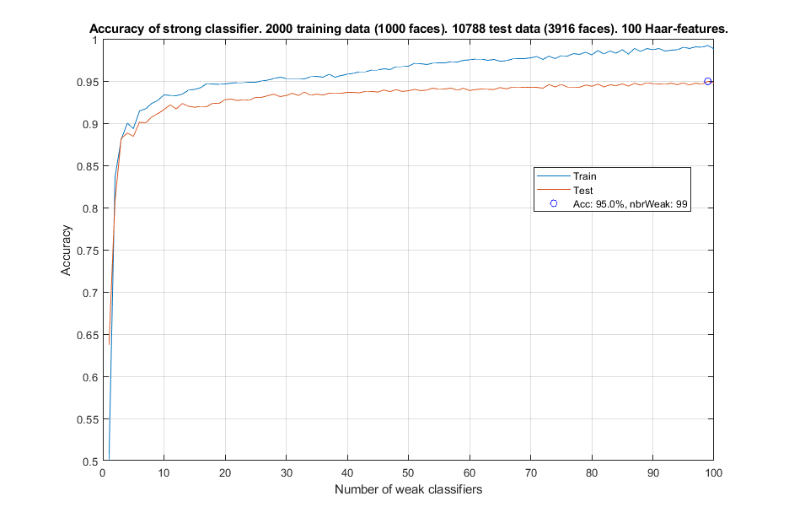

1. **How many weak classifiers did you use when training? How many of them did you use for the final strong classifier? Motivate your choices.**

We used 100 weak classifiers when training the neural network and 99 for the final strong classifier. Looking at the plot in the previous question we can see that the accuracy of both the training and test data kept increasing as with an increasing number of weak classifiers. The accuracy might have been even better if even more weak classifiers were used. However, since an accuracy of 95% already was achieved, surpassing the targeted accuracy of 93%, we decided that 99 weak classifiers gave a satisfactory result.

1. **What is the accuracy on the training data and test data after applying the optimized strong classifier? Discuss your choice of hyperparameters and how they influence the accuracies.**

The accuracy is 99.1% on the training data and 95.0% on the test data.

A low number of Haar-features will greatly decrease the accuracy in most cases. Since these are generated randomly, many needs to be generated to increase the probability that they will produce a good classifier. Since only the best filters are chosen, the algorithm performs by generating as many as possible. However, this will drastically increase the training time of the network for a very small increase in performance. In our case, only 65 of the 100 features were used at least once by the weak classifiers. 100 seems to be well over what is needed to consistently get a good enough result.

2000 training images produced the best result we accomplished. More training images resulted in overfitting.

As mentioned in the previous question, more weak classifiers might have resulted in a better result since the accuracy still seem to increase as weak classifiers increase. We did run this test a few times and the highest accuracy was usually achieved with fewer than 100 weak classifiers. Increasing the number of weak classifiers indefinitely will not produce a better result.

1. **Plot the Haar-features selected by your classifier (one for each weak classifier). If you have many weak classifiers, select some representative subset. Can you think of why they would be useful for classifying faces?**

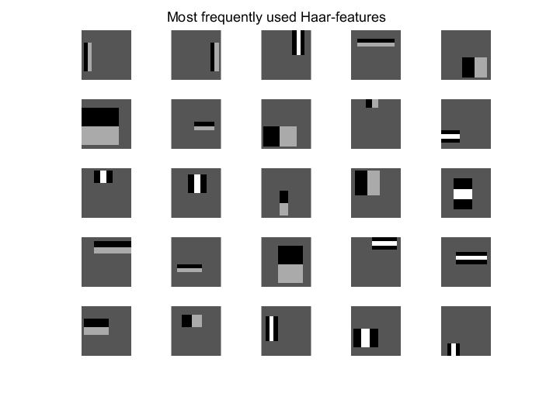

These are the most frequently used Haar-features. The most used, 8 times, is in the top left corner. We believe these would be useful for classifying faces because the rectangles usually are positioned at high contrast places in most of the faces. Looking at the two top features, they seem to frame either side of a face well. Looking at the fourth feature, it seems to be places where the eyes in a face would usually be located.

1. **Plot some of the misclassified faces and non-faces that seem hard to classify correctly. Why do you think they are difficult to classify?**

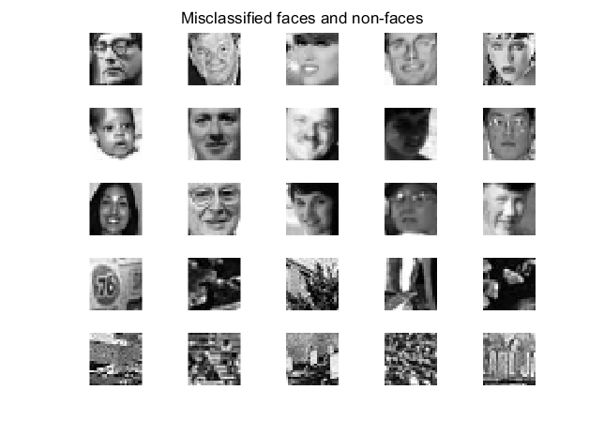

The faces have some features that differs from most other in the dataset. It could be a difference in zoom, rotation, lighting etc. A different zoom and rotation would make the Haar-features framing the face misclassify the image. Having a reflection in a pair of glasses would make Haar-features located at the eyes misclassify the image. The misclassification of non-face images might be more random. The image in position [4,1] above have an oval shape which resembles the shape of a face. Other than that, it seems very random.

1. **Are your results reasonable? Can you think of any way to improve the results?**

Yes, our results are reasonable. Since features are generated at random and many of the non-face images seem random, it cannot be expected to find a perfect solution. One way to improve the result might be to save the best Haar-features during the training and use them in another iteration of training. This might increase the quality of the Haar-features after a few iterations.

1. **Can we expect perfect results? Motivate your answer.**

We can not expect a prefect result. There is always some random noise that could be classified as a face due because of its random color distribution. If all faces in the data set were perfectly normalized in zoom, rotation, and lighting there might be possible to eliminate all false negatives. However, it cannot be expected with this data set.